Q.5) In left & right-skewed data, what is the relationship between mean, median and Mode?

A [**left-skewed distribution**](https://www.statisticshowto.com/probability-and-statistics/skewed-distribution/#SkewLeft) has a lengthy tail on the left. Distributions that are negatively skewed are also known as left-skewed distributions. This is due to the number line having a significant negative tail. Additionally, the peak is to the left of the mean.

A [**right-skewed distribution**](https://www.statisticshowto.com/probability-and-statistics/skewed-distribution/#SkewRight) is right and long-tailed. Positive-skew distributions are another name for right-skewed distributions. That is as a result of a lengthy positive tail on the number line. Additionally, the mean is to the right of the peak.

.

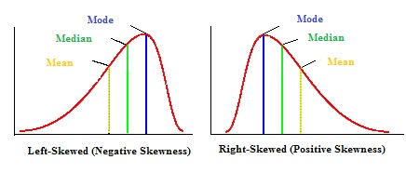

Mean and Median in Skewed Distributions

The mean and median have the same value in a normal distribution, however in a skewed distribution, they have distinct values:

The mean will be located to the left of the median in a left-skewed, negative distribution.

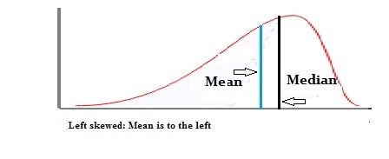

The median will be to the right of the mean in a right-skewed distribution. The median will be to the right of the mean in a right-skewed distribution.

